SMSC Calendar 2019 - 2020
Date | Event | Aim
13th September | M & M Productions – The Jungle Book  Children in Years 2 to 6 will watch a performance in school of the classic text ‘The Jungle Book’. This will round off a whole school unit of Literacy work based on the novel. | Cultural  - To participate in a live theatre performance
27th September | MacMillan Coffee Morning  Our Reception and Year 1 children will plan and host fundraising activities for the parents to raise money for charity. | Social  - To raise awareness of people who are fighting long term and life-threatening health issues.
10th October | Y6 – IMPS  Children in Year 6 will work with Health and Safety visitors to learn about keeping themselves and others safe in the community. They will learn how to administer CPR and place casualties in the recovery position and contact emergency services.  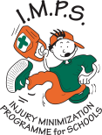 | Social & Moral  - To provide pupils with skills that they can use in their communities  - To develop an understanding of how their actions can impact on others
5th October | Harvest Festival  Our whole school will collect food donations to make up harvest parcels to be delivered by our Y6 children to pensioners in the local community. We will celebrate Harvest festival with parents in a shared church service at St. James’ Church. | Spiritual & Moral  - To understand the importance of harvest  - To understand how we can support those who are in need  - To promote relationships with the local community
22nd October | Y5 – Hull Minster – Michelangelo Exhibition  Year 5 pupils will visit the Hull Minister to view an exhibition of Michelangelo’s work. Supported by artists they will then use a range of techniques to create their own version of the fresco from the Sistine Chapel. | SMSC  - To develop learn more about a significant artist and his work  - To develop artistic skills to re-create versions of a fresco in the Sistine Chapel  - To support learning in RE about places of worship
8th & 11th November | Remembrance Day Hull-a-baloo  Children in Years 1 to 6 will participate in an afternoon of drama, art and practical activities to learn more about the history of the World Wars, as the first event leading towards the 75 year anniversary since VE Day.  Armistice Day  The whole school will make a poppy, which they will lay during a whole school collective worship service. The whole school will participate during this service in a moment of reflective silence. | SMSC  - To help children understand the importance of commemoration  - To show respect for the service of others to their country
15th November | Children in Need  Our Y6 children will plan and host fundraising activities for the whole school to raise money for charity. Children will learn about the work of the charity and how their donations can help others. | Social  - To raise awareness of children who are less fortunate or living with long term health issues  - To enable pupils to support other children
WB 11th November | Anti-bullying and Road safety week  The school councillors, buddies and our Learning Mentor will lead events, and work with the local PCSO, across the school to raise awareness of how to address and prevent bullying issues. In addition, our road safety officers and Learning Mentor will deliver messages to all pupils on how to stay safe near roads. | Social & Moral  - To raise awareness of, and provide strategies for, dealing with bullying issues  - To ensure children have practical advice on how to stay safe in a variety of situations
December | Advent/Christmas  The whole school will participate in activities and acts of collective worship to reflect on the season. Our Y6 children will also lead carols and lessons during the church service at St. James’ Church.  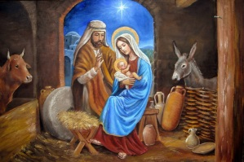 | SMSC  - To reflect on and understand the true meaning of Christmas for Christians  - To learn about the significance of various traditions during the advent and Christmas season
12th December | Pantomime – Aladdin  Children from Y1 to Y6 will attend a pantomime performance of Sleeping Beauty. They will have the opportunity to watch a live performance by a professional company in a theatre environment. | Cultural  - To participate in a live theatre performance
7th February | Song for Hull  A choir of children from Year 5 and Year 6 will take part in the Song For Hull event at the Bonus Arena. They will join with 11 other school choirs and perform for an arena audience during the evening.  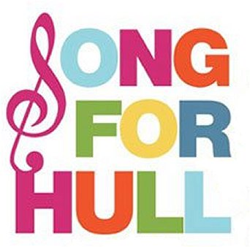 | Cultural  - To participate in a live performance with children from other schools
Beginning Wednesday 26^{h} February and through to Easter. | Lent and Easter  The whole school will participate in activities and acts of collective worship during this time.  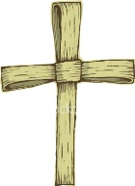 | SMSC  - To reflect on and understand the significance of Lent and Easter
5th March | Farewell to the Archbishop  A representative group of pupils will take part in an event at Archbishop Sentamu Academy to wish the Archbishop of York farewell and good luck as he moves on to the next stage of his ministry.  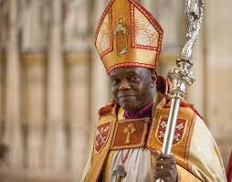 | SMSC  - To participate in and celebrate the Archbishop of York’s time in his role
6th March | World Book Day  Our whole school will take part in a celebration of Literature through a range of book based activities. | Cultural  - To discuss books pupils enjoy and further develop their appreciation and enjoyment of reading for pleasure.
5th July | Leavers’ Church Service  Our Y6 children will lead our church service at St. James’ Church, by reflecting on their memories and achievements during their time at St. James’ School.  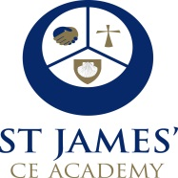 | SMSC  - To reflect on and celebrate the time the Year 6 children have spent at St. James.

Further events to follow in the Summer term.

