British Values Calendar 2019 - 2020
Date | Event | Aim
September | Election on School Councillors  Each class will participate in nominating, and selecting their class school council representatives. Pupils wishing to be elected will explain their reasons for wanting to represent their class and then children will select their councillors by voting.  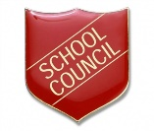 | Democracy
September | Selection of Buddies, Road Safety Officers and Digital Leaders  Pupils in Year 5 and Year 6 will complete application forms to be considered for selection as Playground Buddies, Junior Road Safety Officers or as Digital Leaders. Representatives will present assemblies and organise activities throughout the year to remind children about safe behaviour while out and about in the local area and when using mobile devices.  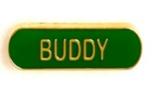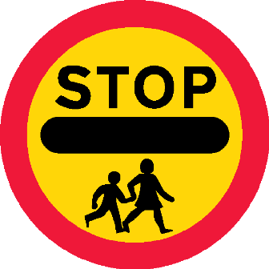 | Democracy & Individual Liberty
24th September | Beverley Races  Our Year 6 children will visit Beverley Racecourse and develop the mathematical skills in a practical setting. They will learn about measures through activities relating to jockeys and around the enclosure. | Individual Liberty
26th September & ongoing | Rackets Cubed Programme  Over a period of Thursday afternoons the pupils in Year 6 will participate in a new initiative at Hull University, combining learning about healthy diet and lifestyles, being introduced to the game of Squash and using the university facilities to participate on STEM lessons. | Individual Liberty
27th September | MacMillan Coffee Morning  Our Reception and Year 1 children will plan and host fundraising activities for the parents to raise money for charity. | Mutual Respect
2nd October | Bishop Burton – Construction  Year 5 children will attend Bishop Burton College to take part in a range of activities with Hobson & Porter, learning about career opportunities in the construction industry. | Individual Liberty
3rd October | BAE Systems visit  Year 6 pupils will visit BAE Systems and learn all about the aircraft construction industry. They will have a tour of the workshops, sit in a Hawk jet, fly a flight simulator and take part in activities related to the science of the aerodynamics of planes. | Individual Liberty
10th October | IMPS  Children in Year 6 will work with Health and Safety visitors to learn about keeping themselves and others safe in the community. They will learn how to administer CPR and place casualties in the recovery position and contact emergency services.  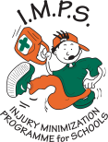 | Mutual Respect & Individual Liberty
5th October | Harvest Festival  Our whole school will collect food donations to make up harvest parcels to be delivered by our Y6 children to pensioners in the local community. | Mutual Respect
15th October | Year 2 Museum Visit  Year 2 pupils will visit the Streetlife museum and participate in a Bridge Building Workshop, to support their topic learning about the Humber Bridge. | Mutual Respect & Individual Liberty
17th October | Pizza Express & St. Mary’s  Our Year 6 children will spend the morning at Pizza Express, learning about a working kitchen and Health and Safety issues followed by creating their own Pizza. They will then visit St. Mary’s Church and learn about a different Church of England place of worship, completing a comparative study to our church. | Individual Liberty & Mutual Respect
22nd October | Humber Bridge visit  Year 1 children will spend the morning at the Humber Bridge, to support their topic learning. They will have the opportunity to walk on and under the bridge, as well as take part in a nature walk in the grounds below the bridge.  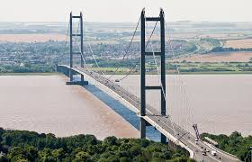 | Mutual Respect & Individual Liberty
7th November | Y4 Museum visit  Children in Year 4 will visit the Hull and East Riding museum to take part in a workshop about the Anglo-Saxons, linked to their topic learning. They will also visit the Streetlife museum to look at how transport has changed in Hull over the years. | Mutual Respect & Individual Liberty
8th & 11th November | Armistice Day/Remembrance  Y1 – Y6 Remembrance Hull-a-baloo  The whole school will make a poppy, which they will lay during a whole school collective worship service. The whole school will participate during this service in a moment of reflective silence. | Individual Liberty & Mutual Respect
WB 11th November | Anti-bullying and Road safety week  The school councillors, buddies and our Learning Mentor will lead events, and work with the local PCSO, across the school to raise awareness of how to address and prevent bullying issues. In addition, our road safety officers and Learning Mentor will deliver messages to all pupils on how to stay safe near roads.  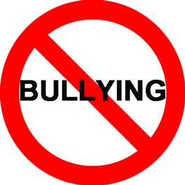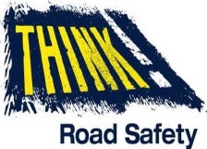 | Mutual Respect, Individual Liberty & Rule of Law
15th November | Children in Need  Our Y6 children will plan and host fundraising activities for the whole school to raise money for charity. Children will learn about the work of the charity and how their donations can help others.  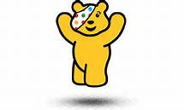  Healthy Lifestyles  Year 3 and Year 4 pupils will take part in weekly sessions, for 4 weeks, learning about the how to eat and exercise well in order to maintain a healthy mind and body. | Individual Liberty & Mutual Respect  Individual Liberty
5th December | Ladies in Pigs  Children in the Opportunities class and Year 3 will work with visitors from the Ladies in Pigs initiative to learn about farming techniques and also cook some simple healthy meals with pork.  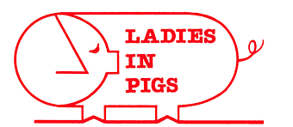 | Individual Liberty
Tuesday Mornings  14th Jan. – 10th March | KCOM – Run with it Programme  Children in opportunities class will attend a weekly session at the KCOM stadium to develop their maths and literacy skills for a real purpose – measuring the pitch, creating presentations and using the team shops for a range of activities.  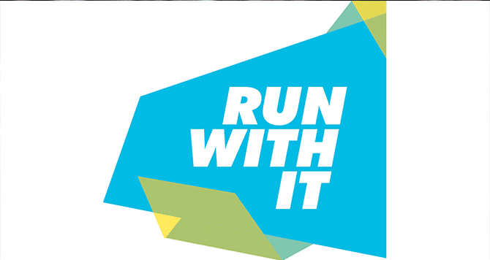 | Individual Liberty & Mutual Respect
30th January | Y3 Roman Visit  Children in Year 3 will visit the Hull and East Riding museum to take part in a workshop about the Romans, linked to their topic learning.  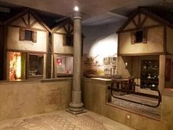 | Mutual Respect & Individual Liberty
7th February | Song for Hull  A choir of children from Year 5 and Year 6 will take part in the Song For Hull event at the Bonus Arena. They will join with 11 other school choirs and perform for an arena audience during the evening.  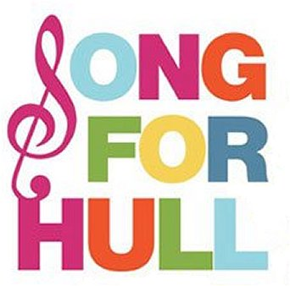 | Individual Liberty
4th March | Y3 Trawling from Hull Visit  Pupils in Year 3 will participate in a Hull Children’s University visit around the city centre to explore the town’s fishing heritage.  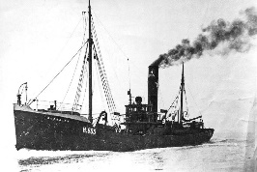 | Mutual Respect & Individual Liberty
18th March | Y5 Sketching Historical Hull Visit  Pupils in Year 5 will pilot a new unit for Hull Children’s University to explore the historical buildings of Hull, looking at their origins and architecture.  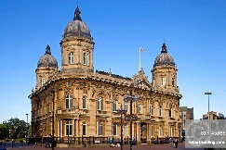 | Mutual Respect & Individual Liberty
2nd April | Y4 Amazon Visit  Pupils in Year 4 will participate in a Hull Children’s University visit to Doncaster to tour the Amazon distribution centre. This is aimed at raising the children’s aspirations and considering jobs for the future. | Mutual Respect & Individual Liberty
WB 4th May | Bikeability  Pupils in Year 5 will participate in Bikeability sessions, learning to ride a bicycle safely on the roads. | Rule of Law and Individual Liberty
24th - 26th June | Butlin’s Residential  Year 5 and Year 6 pupils will have the opportunity to take part in a residential visit to Butlins. They will participate in a range of outdoor activities that are unable to be delivered in the school. | Individual Liberty

Further events to follow in the Summer term.

